**CEIR System**

**User Guide**

Version 0.1

© Sterlite Technologies Ltd.

**CONFIDENTIALITY CLAUSE**

No part of this document may be reproduced, stored in a retrieval system or transmitted in any form or by any means, electronic, mechanical, recording, photocopying or otherwise without the prior written permission of Sterlite Technologies Ltd.

The contents of this document are provided to **“DMC”** in confidence solely for the purpose of evaluating possible business relationship.

**ALL RIGHTS RESERVED**

Sterlite Technologies Ltd.

Elitecore, Block 6, Magnet Corporate Park,

Nr. Sola Flyover, Thaltej

Ahmedabad–380059, India

**TRADEMARKS**

All the brand names and other products or services mentioned in this document are identified by the trademarks or service marks of their respective owners.

**DISCLAIMER**

The document is designed as per the scope of DMC., contents in this document are mutually agreed by Sterlite Tech & DMC. This document (Solution Requirement Specifications) Supersede all the previously shared documents (SOW & Previous SRS versions). SRS (Solution Requirement Specifications) is the base of development & configurations. Anything over & above this signed off SRS shall be mutually discussed and agreed keeping DMC business mission accomplishment as priority, any significant additions in scope shall be mutually discussed and handled separately as a change request. New change request should not impact on the delivery & commercial milestones of this project.

| Point of Contact | | | |
| --- | --- | --- | --- |
| Name |  |  |  |
| Title |  |  |  |
| Email |  | Skype Id |  |
| Mobile |  |  |  |

|  |  |
| --- | --- |
| Target Audience | |
| 1 | CEIR Agency |
|  |  |
|  |  |

|  |  |  |
| --- | --- | --- |
| Reference& Resources | | Remark |
|  |  |  |
|  |  |  |
|  |  |  |

|  |  |  |
| --- | --- | --- |
| Open Points Tracker | | Remark |
|  |  |  |
|  |  |  |
|  |  |  |

**VERSION CONTROL AND DOCUMENT HISTORY**

|  |  |  |  |  |  |
| --- | --- | --- | --- | --- | --- |
| **#** | **Document Version** | **Date** | **Owner** | **Document Status** | **Remarks** |
| 1 | 0.1 |  |  |  |  |
|  |  |  |  |  |  |
|  |  |  |  |  |  |
|  |  |  |  |  |  |
|  |  |  |  |  |  |

Table of Contents

1 Overview 6

1.1 CEIR Integration Architecture 7

1.2 Integration – Redundancy Architecture 7

2 User 8

3 Physical Architecture 8

3.1 VLAN 9

3.2 IP Plan 9

3.3 Directory Structure 9

4 Server Overview - Description 9

4.1 Signaling Server 10

4.2 Portal Server 10

4.3 Reporting Server 10

4.4 Application Server 10

5 Redundancy Architecture 10

# Overview

This document describe an overview about the CEIR Application. The key objective and functionality of CEIR application is to **block (or maintain black listing for blocking and grey listing for monitoring) the devices in multi operator’s environment** homogeneously without any preference or selection for multiple reasons or objectives from using the network services like voice,SMS, GSMd data(not Wi-Fi data).

The CEIR product architecture is as follows:

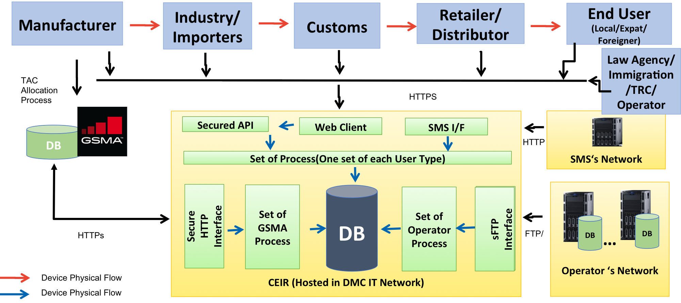

There are mutliple Stakeholders in the CEIR system. Such stakeholder like manufacturer, importers, customs interface with CEIR system using a HTTP based web browser

The system interface with GSMA for blacklist and device details over HTTPs interfae.

The CDR are collected thru the Operator network by Sterlite mediation system and are parsed into a uniform format and shared over ftp interface with CEIR system at regular intervals.

The system send out notification to users over SMS/email interface.

The key components of the CEIR application is as follows:

1. CDR Processing – The CDR is collected from the Sterlite system and are parsed at regular intervals. Post parsing, the rules are applied and then the IMEI database is built.
2. Web Server for interface with Stakeholders – All the stakeholder interact with the CEIR system over web interface
3. Reporting – There are multiple device related reports created in the system for mutliple purposes.

## CEIR Integration Architecture

The CEIR system interface with following elements to implement the functionality

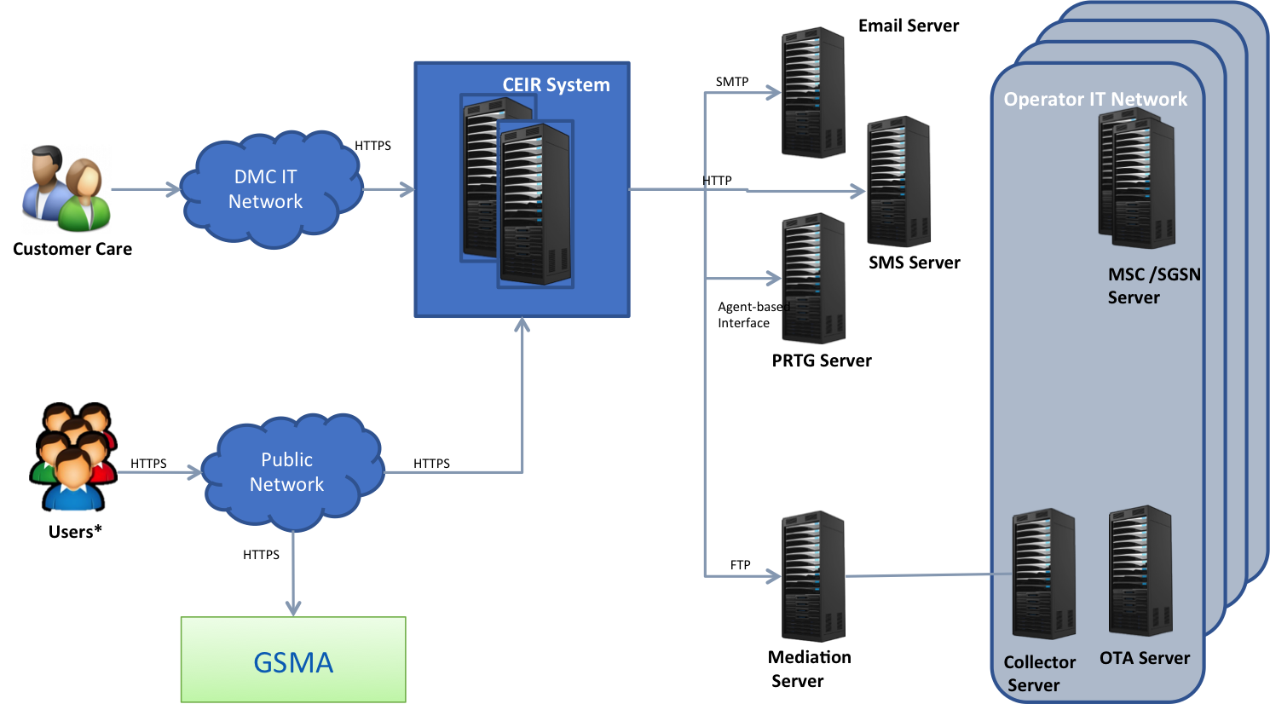

For the current implementation, the portal is not accessible over public network. Both internal user like Customer care or stakeholder /user are connected over internal DMC IT network.

The CEIR system interface with DMC ‘s PRTG server for service monitoring.

The following is the integration details:

* ETL for Operator CDR via FTP
* Bulk Aggregator for sending SMS over HTTP
* Email Server for sending e-mails over SMTP
* PRTG for alerts over SSH
* GSMA over HTTP(s) for blacklist/TAC details

|  |  |
| --- | --- |
| Node | Integrated with |
| ETL | Signaling Pair |
| SMS | Portal Server |
| Email | Portal Server |
| PRTG | All server |
| GSMA | Portal Server |

## Integration – Redundancy Architecture

The following is the redundancy architecture

|  |  |  |  |
| --- | --- | --- | --- |
| Node | CEIR Mode | Connectivity | Handling |
| ETL | Server | Mediation will send ftp file on the Virtual IP (service traffic) on the signaling server. One of the signaling server will have the virtual IP |  |
| SMS | Client | SMS will expose a URL which will be redundant | In case IP is not reachable, the message is tried 3 times before marking it failure |
| Email | Client | Email server is assumed to be highly available | In case IP is not reachable, the message is tried 3 times before marking it failure |
| PRTG | Server | PRTG will run SSH command virtual IP (management traffic) on all the server where the scripts are placed |  |
| GSMA | Client | GSMA will expose a URL which will be redundant | In case IP is not reachable, the request will be marked as failed |

# User

This section describes the multiple types of users which interact with the system. There are 3 kind of users

1. External users – Stakeholder user like importer are part of such user. These user are the one which are not part of DMC organization. The list of such stakeholder include manufacturer, custom, lawful agency, operator, TRC, importers, distributors, retailer and end users.
2. Internal users – User like system admin are part of such users. These user are the one which are part of DMC organization. The list of such stakeholder include system admin, CEIR admin, customer care agents etc
3. System user – These user are system user which are created for system to system integration. FTP user is created and shared with Sterlite Mediation system to send the CDR files over sftp interface.

# Physical Architecture

This section describe the physical deployment of the CEIR application. There are total 8 servers. The DB server are shared.

The 8 server are divided into 4 pair as follows:

1. Signaling Server
2. Portal Server
3. Reporting Server
4. Application Server

## VLAN

There are 2 VLAN: One for Management and one for Service.

Service VLAN will be used to carry all the service related traffic. Management VLAN is used for monitoring and connnecting with servers.

## IP Plan

Each server has a physical IP. There is a service virtual IP configured on each server pair. So there are total 4 virtual IP configured.

|  |  |  |  |
| --- | --- | --- | --- |
| SN | Server | IP | Virtual IP |
| 1 | App Server 1 |  |  |
| 2 | App Server 2 |  |  |
| 3 | Portal Server 1 |  |  |
| 4 | Portal Server 2 |  |  |
| 5 | Signaling Server 1 |  |  |
| 6 | Signaling Server 2 |  |  |
| 7 | Reporting Server 1 |  |  |
| 8 | Reporting Server 2 |  |  |

## Directory Structure

The section describe the key folder where the files are received from mediaton and files are maintained after processing

|  |  |  |
| --- | --- | --- |
| SN | Description | Value |
| 1 | Base Path Where the Software is deployed | /u01/ on all production server  /opt on all test server |
| 2 | Base path where the logs are maintained | /u02/ceirdata/ on all production server  /opt on all test server |
| 3 | Base Path where the file are saved uploaded by user | /u01/ceirdata/ |

# Server Overview - Description

This section description the server description .

## Signaling Server

The signaling server process the CDR and build the IMEI database. For more details, refer to Sterlite_User_Guide_1.0_Signaling Server User Guide

## Portal Server

The portal server process the user request and also build the inactive IMEI database and. For more details, refer to Sterlite_User_Guide_1.0_Portal Server User Guide

## Reporting Server

The reporting server generate all the required reports For more details, refer to Sterlite_User_Guide_1.0_Reporting Server User Guide

## Application Server

These server are for future use

# Redundancy Architecture

This section describes how the redundancy is managed

There is a virtual IP which is managed by Heart beat manager. Virtual IP is up and running on one server. The process can be configured in active-active mode or active-standby mode based on the requirement.

